**SERVICE NOW PROJECT DOCUMENTATION**

**Mahendra Car Showroom Automation System**

**Project Documentation**

**Submitted By**

**Team ID:** LTVIP2026TMIDS85044  
**Team Size:** 3

**Team Leader:**  
Tummalapalli Iswarya

**Team Members:**  
Seepani Veena Sree  
Sravani Neruturi

**Mentors**

**Industry Mentor:**  
No Mentor Assigned

**Faculty Mentor:**  
M Ganesh

**Internship / Organization**

SmartInternz – Project Phase

**Platform Used**

ServiceNow Platform

**Academic Year**

2025 – 2026

**1.Introduction**

Digital transformation has become a core requirement for modern business operations. Organizations that continue to rely on manual, paper-based processes face operational inefficiencies, delays in decision-making, communication gaps, and data inconsistencies. Traditional approval systems involving physical forms, phone calls, and email follow-ups lack transparency, scalability, and real-time tracking capabilities.

To address these operational challenges, this project implements a structured and automated booking system using the ServiceNow platform. The Mahendra Car Showroom Automation System is designed to digitize and streamline the vehicle booking lifecycle — from customer request submission to multi-level approval and final fulfillment tracking.

This solution replaces the traditional showroom-based booking model with a centralized, workflow-driven automation framework. Customers can submit booking requests digitally through the Service Catalog, while internal stakeholders manage approvals and task execution through automated routing and notifications.

The system introduces standardization, governance, and accountability into the booking process by leveraging ServiceNow’s Service Catalog and Flow Designer capabilities.

**Project Objectives**

The Mahendra Car Showroom Automation System focuses on:

• Process automation to eliminate manual routing and paperwork  
• Workflow standardization to ensure consistent booking handling  
• Role-based approval management for structured governance  
• Secure data handling with controlled access and audit logs  
• Automated notifications to improve communication transparency  
• Centralized tracking of booking records and status updates  
• Reduced processing time and improved operational efficiency  
• Enhanced customer experience through digital self-service

**2.Project Overview**

The Mahendra Car Showroom Automation System is a Service Catalog–based application developed within ServiceNow. The solution allows customers to browse available car models and submit booking requests through the Service Portal. Once submitted, the request automatically enters a structured workflow for internal review and approval.

Previously, the showroom handled bookings manually:

* Customers filled paper forms
* Sales team verified details
* Supervisor approval was taken physically
* Emails were sent manually
* Records were stored separately

This approach resulted in:

* Delayed approvals
* Human errors
* No centralized tracking
* No transparency
* Lack of audit history

The implemented system resolves these issues by introducing automation through Flow Designer. Every booking request is now traceable from submission to completion.

**Key Functional Capabilities**

* Online car catalog browsing
* Booking request submission
* Automated catalog task creation
* Two-level approval workflow
* Conditional rejection handling
* Automated email notifications
* Complete audit trail maintenance
* Role-based secure access

**3. System Architecture**

The architecture follows a layered model within the ServiceNow platform to ensure scalability, maintainability, and security.

**3.1 Presentation Layer**

The Presentation Layer is implemented using the Service Portal.

Customers interact with:

* Car catalog
* Car item detail pages
* Booking form
* Confirmation page
* My Requests section

The interface is responsive and accessible from both desktop and mobile devices. It ensures a simple user journey:

1. User logs into the portal
2. Selects Mahendra catalog
3. Chooses a car model
4. Submits booking details
5. Receives confirmation with request number

The user interface hides backend complexity and ensures seamless interaction.

**3.2 Business Logic Layer**

The core automation is implemented using Flow Designer.

The flow is triggered automatically when a Requested Item record is created in the system.

Workflow execution includes:

* Trigger: Requested Item Created
* Condition: Verify selected catalog
* Create Catalog Task
* Ask for Approval (Sales Person)
* If Approved → Continue
* If Rejected → End flow + Send rejection notification
* Ask for Approval (Supervisor)
* If Approved → Mark request successful
* Send success email
* Close task

This structured automation ensures:

* No manual routing
* No dependency on email forwarding
* No missed approvals
* Clear approval state tracking

Each decision point in the workflow is controlled through IF conditions to ensure logical branching.

**3.3 Data Layer**

The solution uses standard ServiceNow tables to maintain structured and relational data.

Primary tables used:

* sc_request
* sc_req_item
* sc_task
* sysapproval_approver
* sys_user
* sys_user_group
* sys_audit

Each booking creates:

* One Request record
* One Requested Item record
* One or more Approval records
* One Catalog Task

All data is stored securely within the ServiceNow database.

The system automatically maintains:

* Record history
* State changes
* Approval comments
* Time stamps
* User references

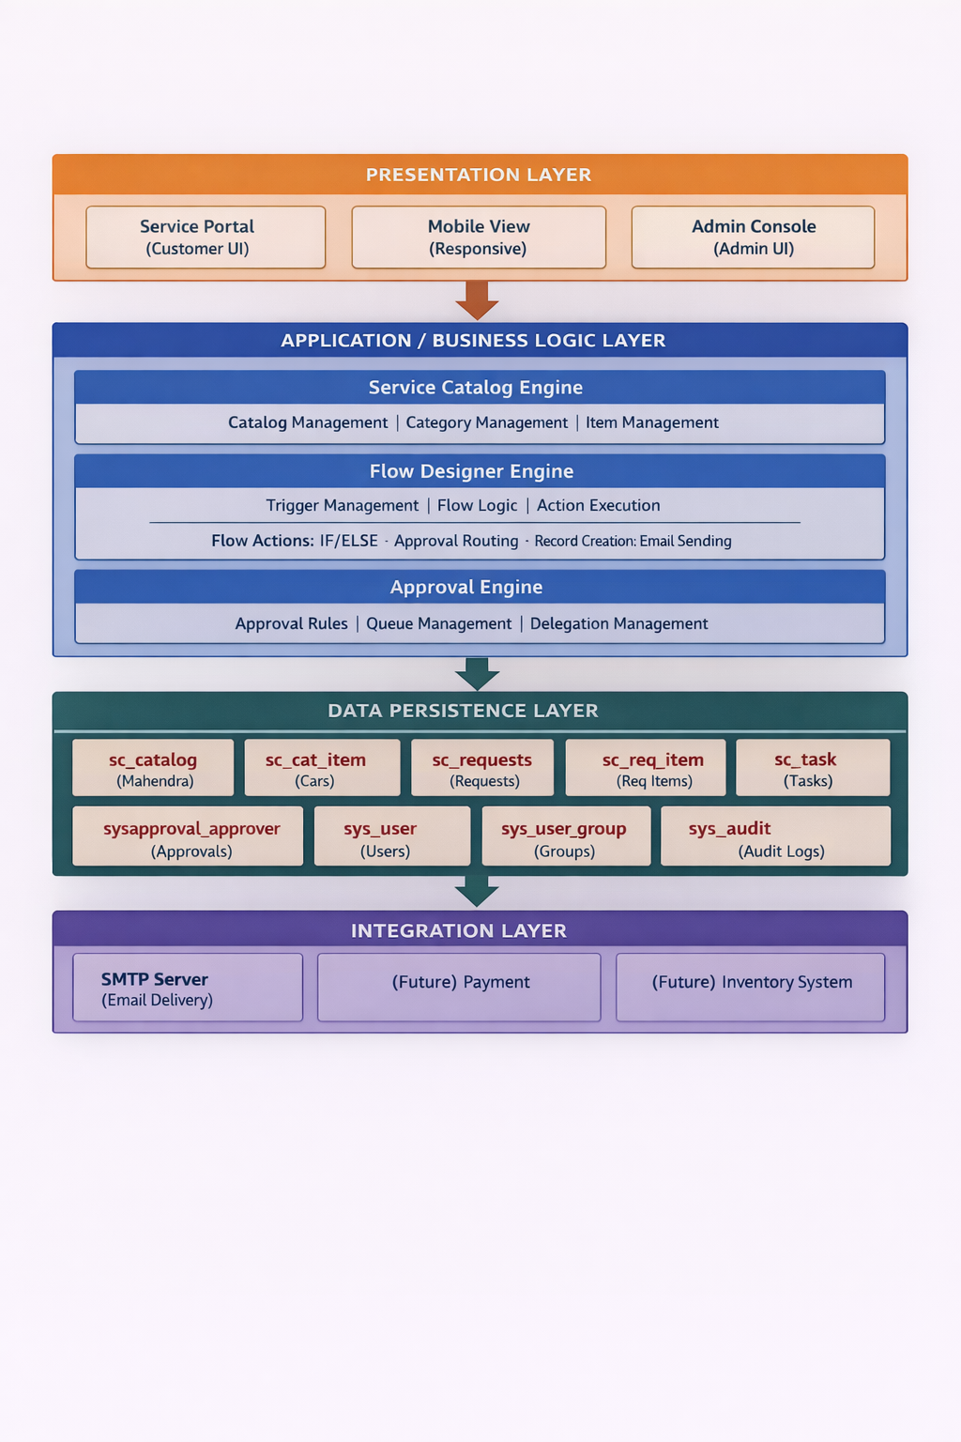

**4. Implementation Details**

The implementation was carried out in multiple structured phases.

**Phase 1: Catalog Configuration**

* Created a new Service Catalog named "Mahendra"
* Added categories such as SUV, Sedan, and Sports
* Created catalog items including Thar, Polo, and XUV700
* Configured pricing and descriptions
* Added images and booking fields

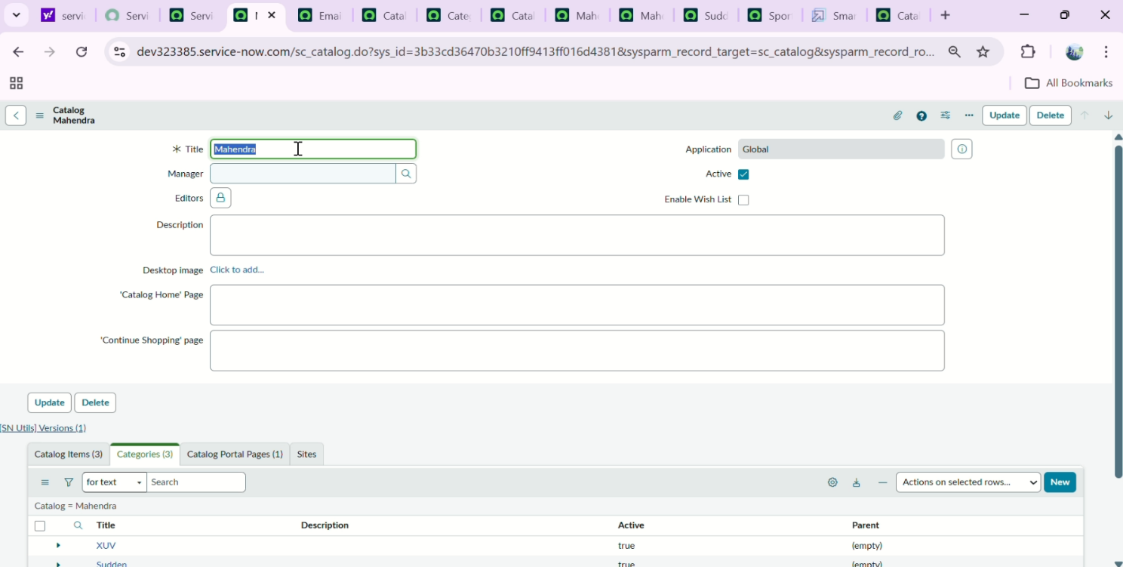

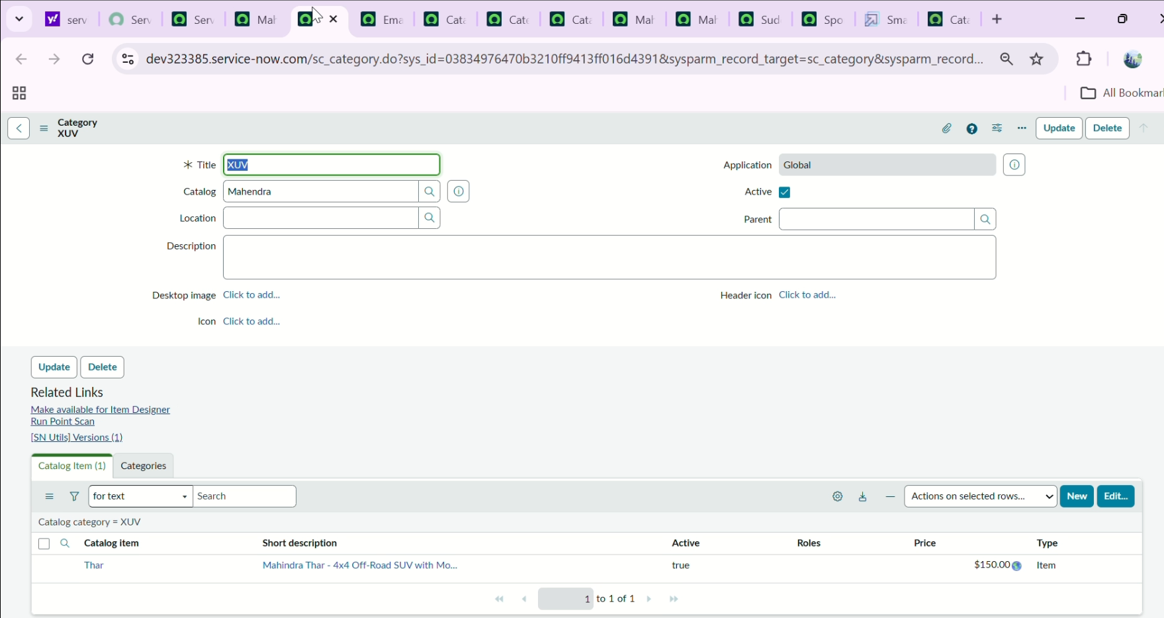

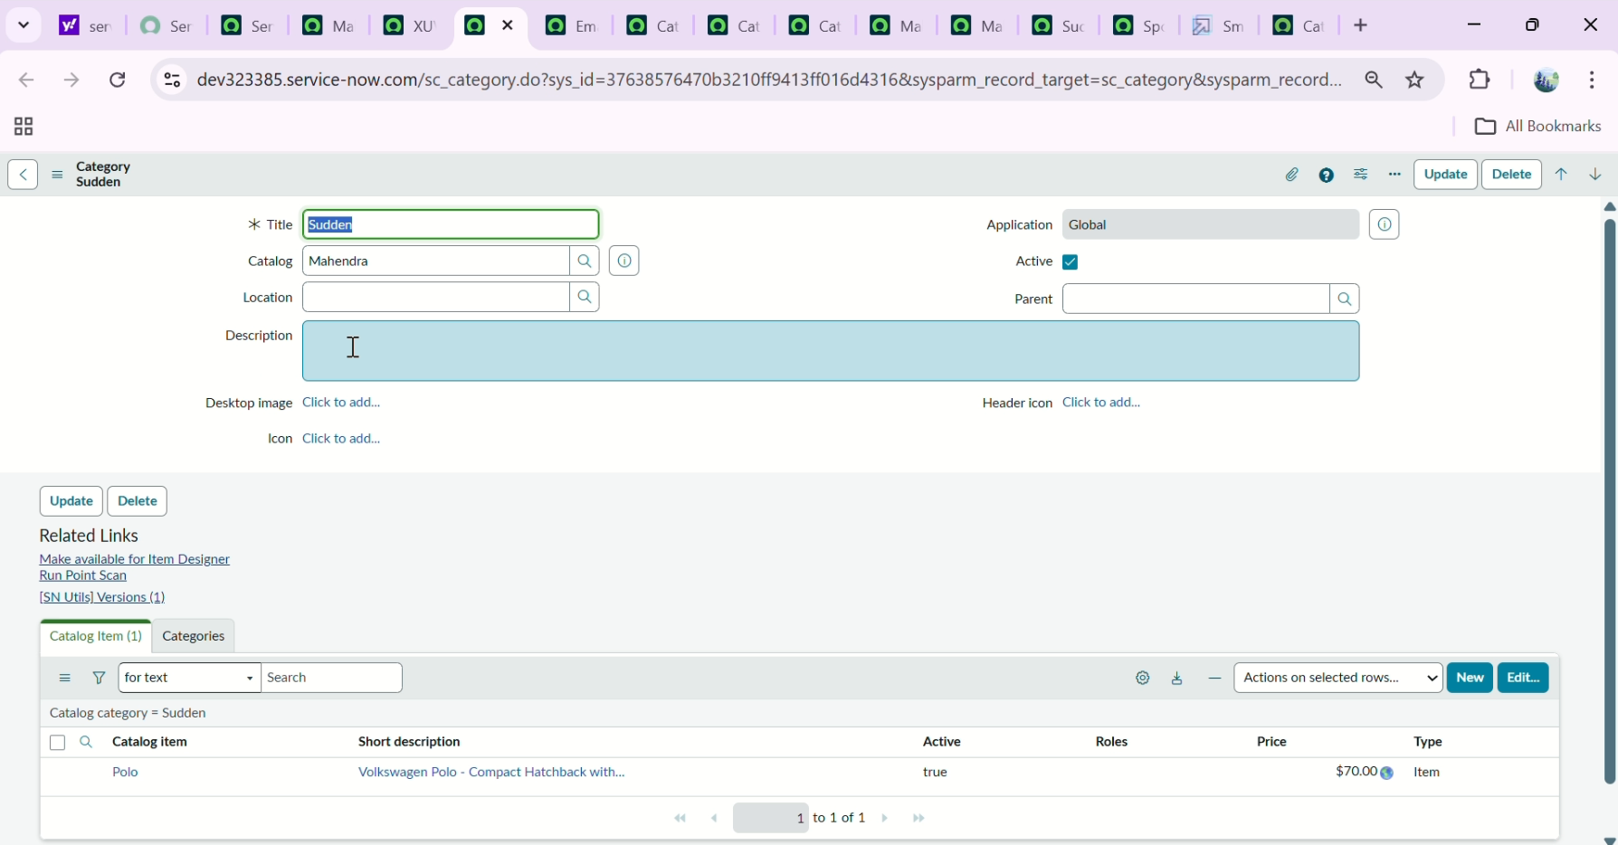

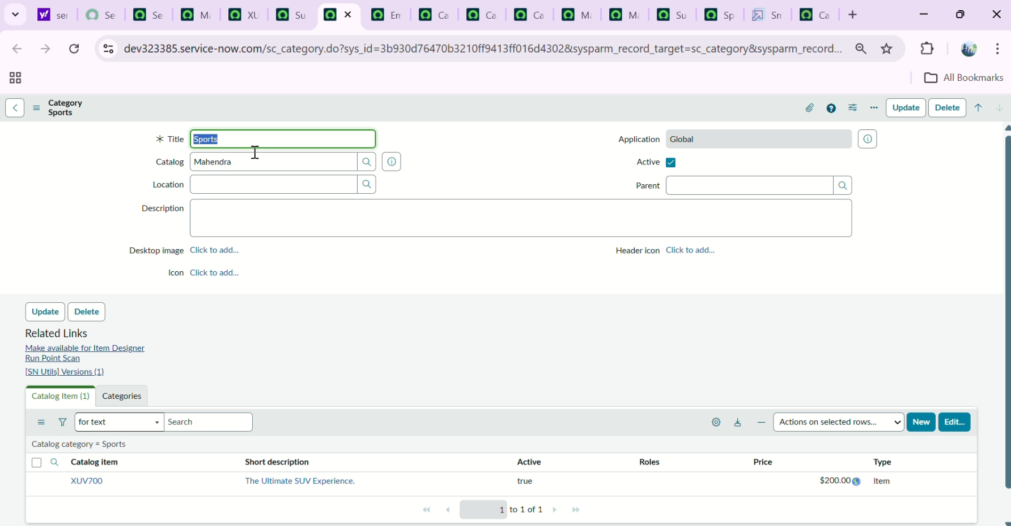

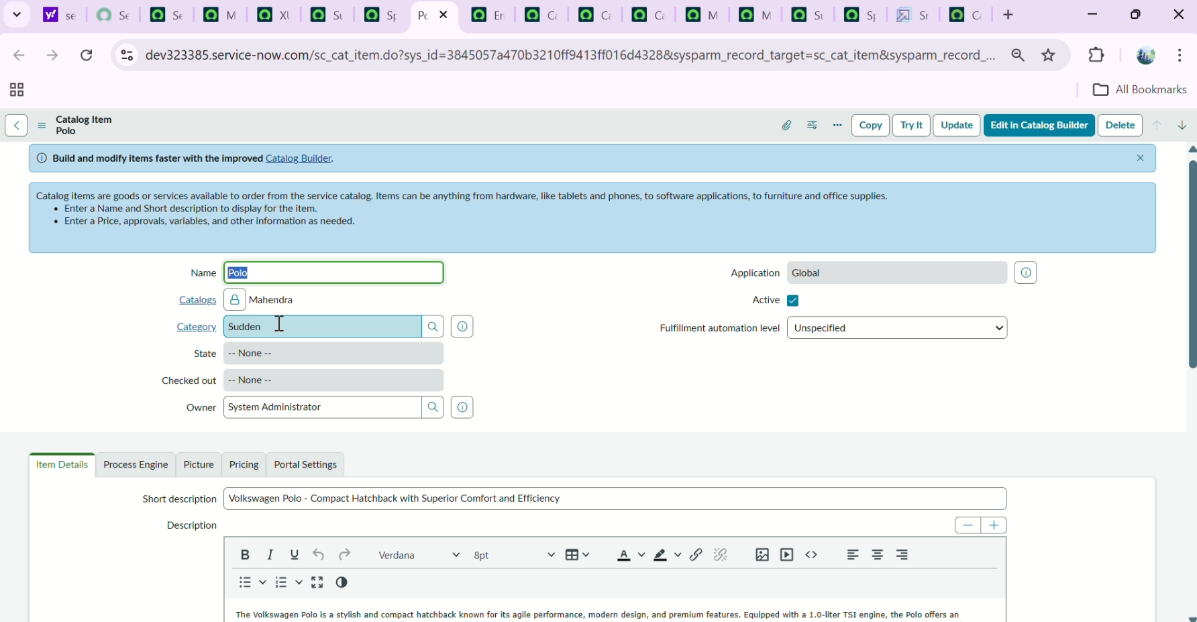

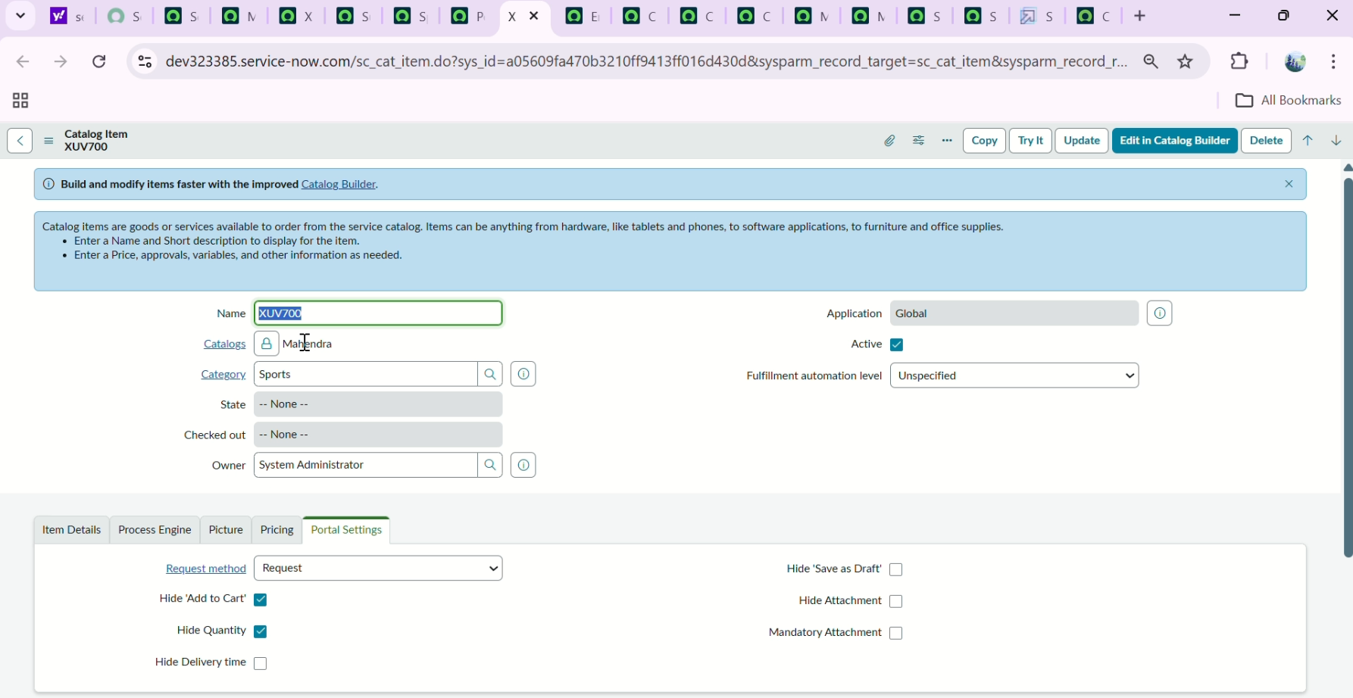

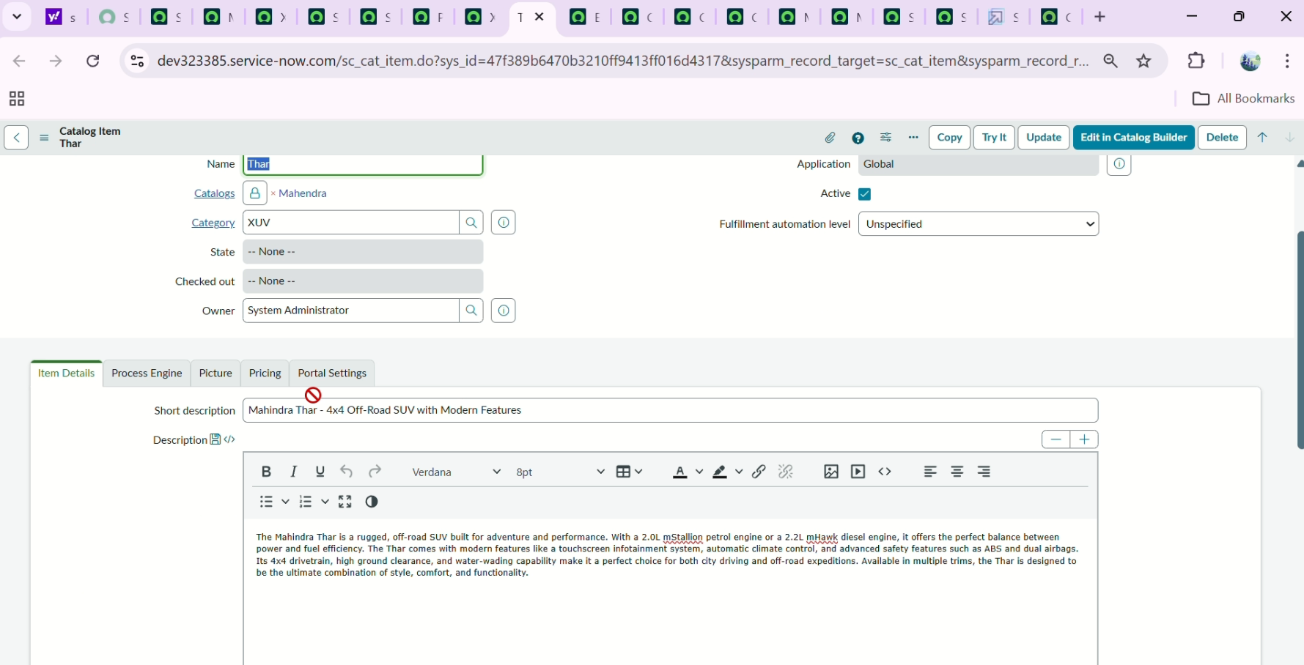

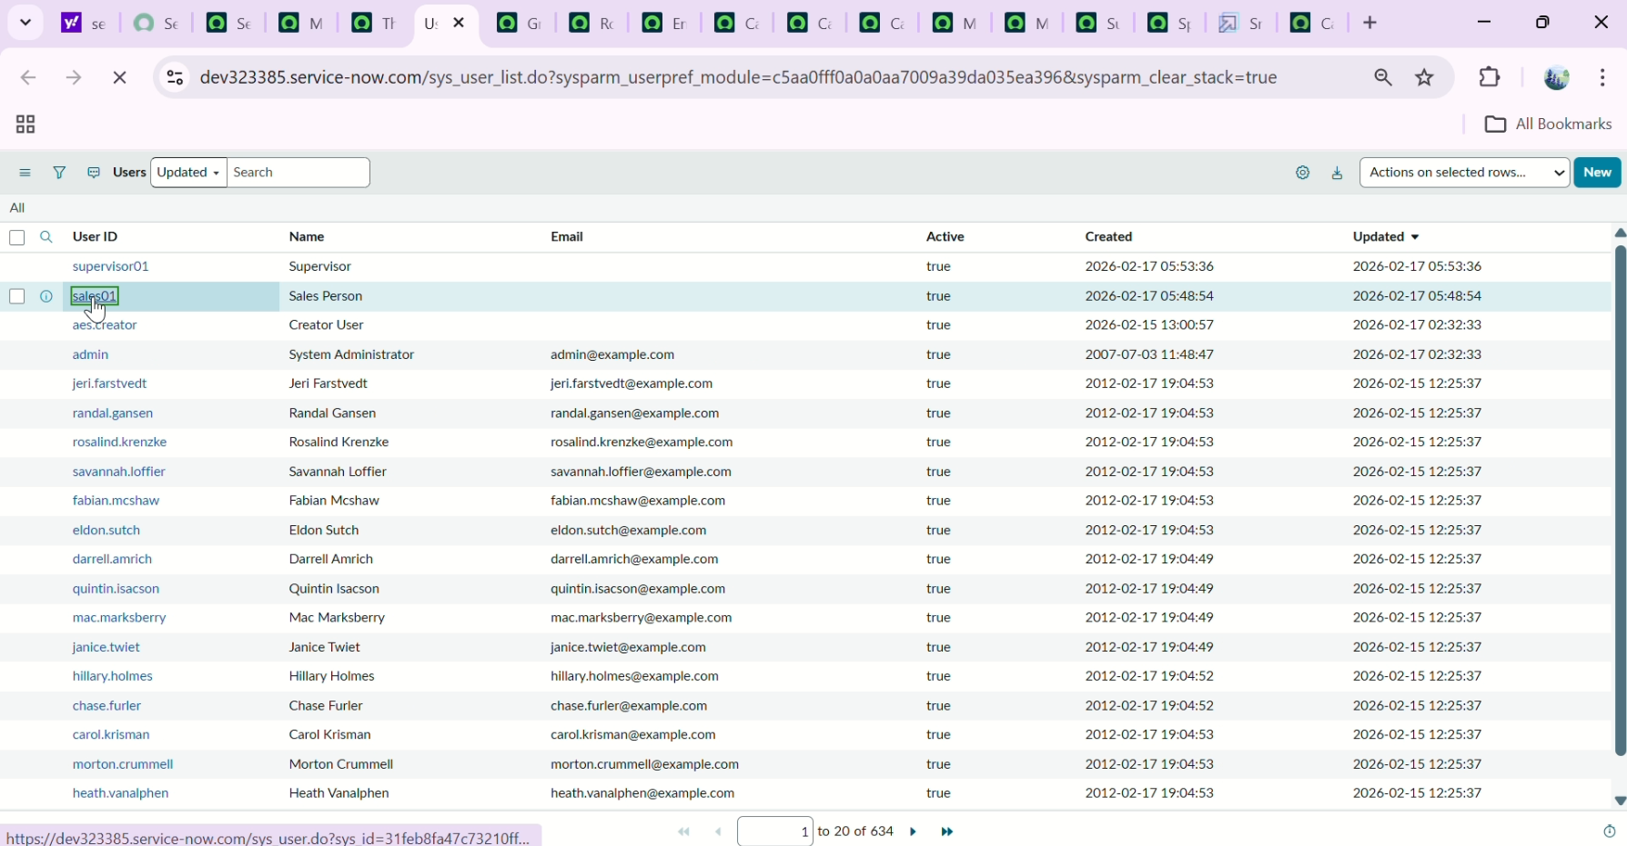

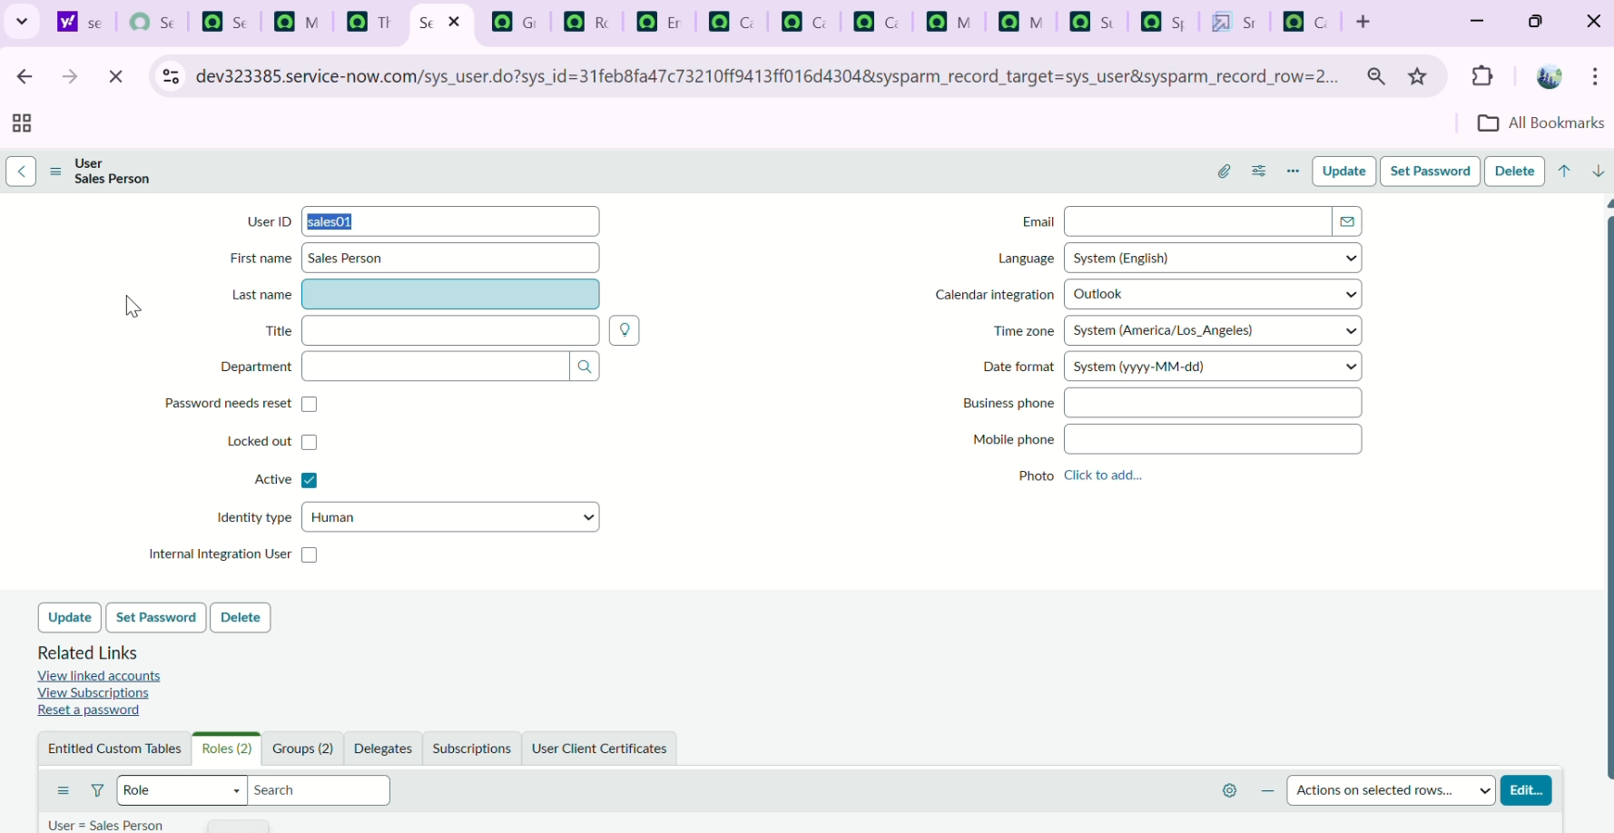

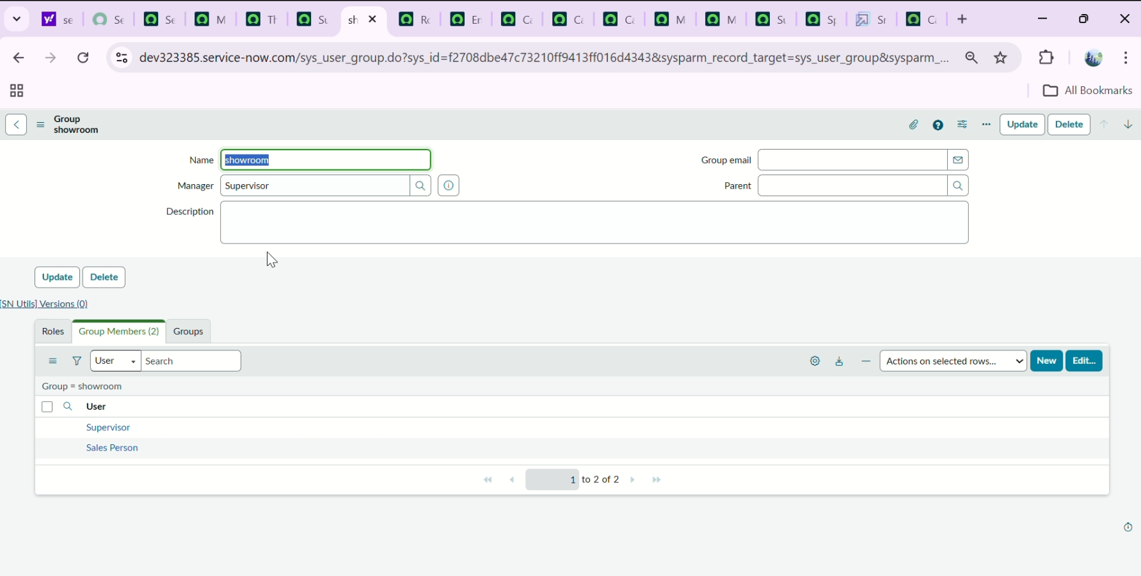

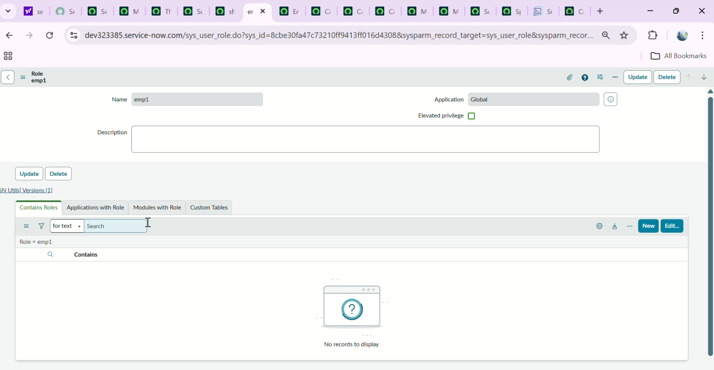

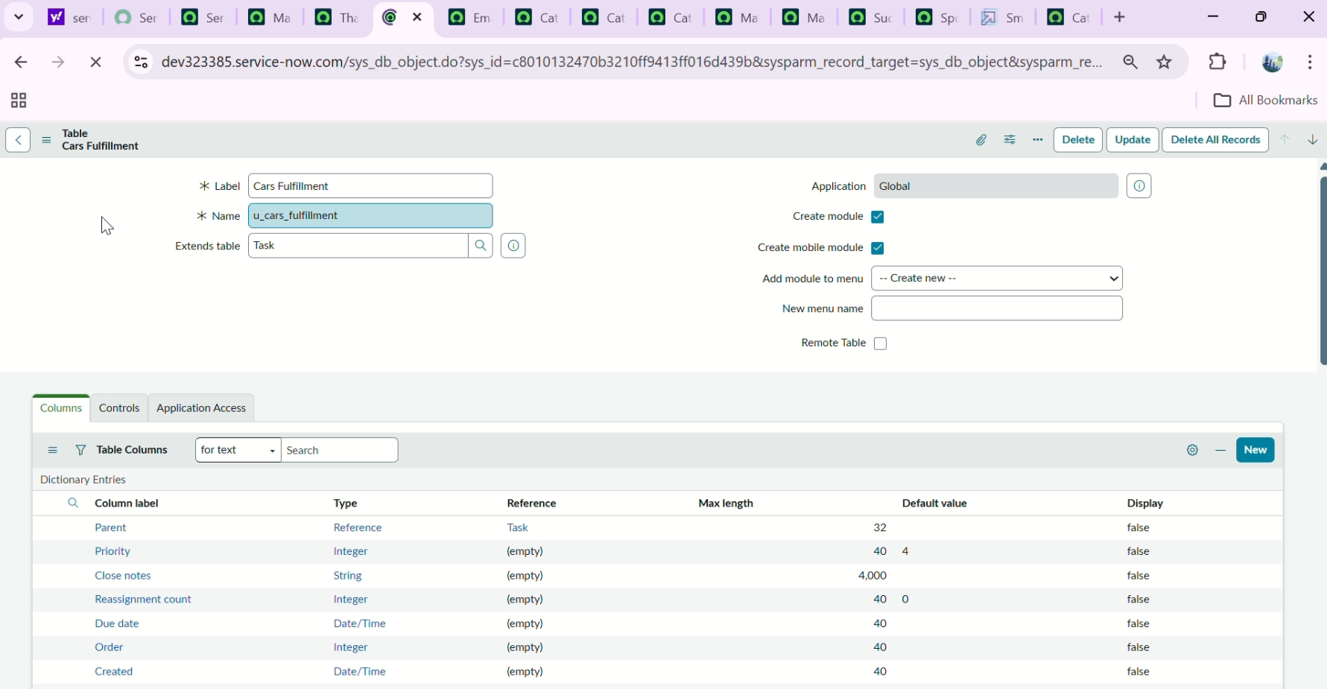

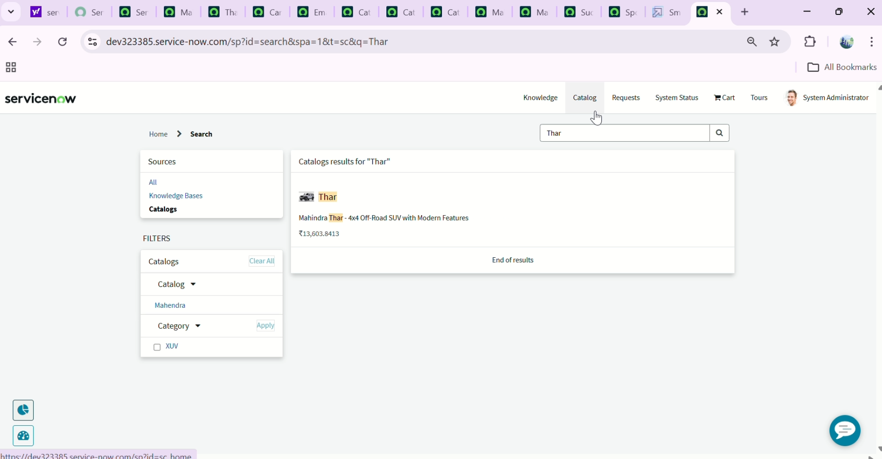

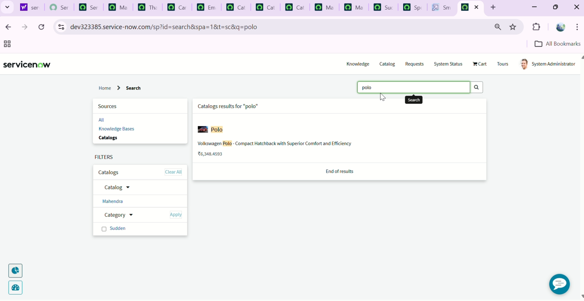

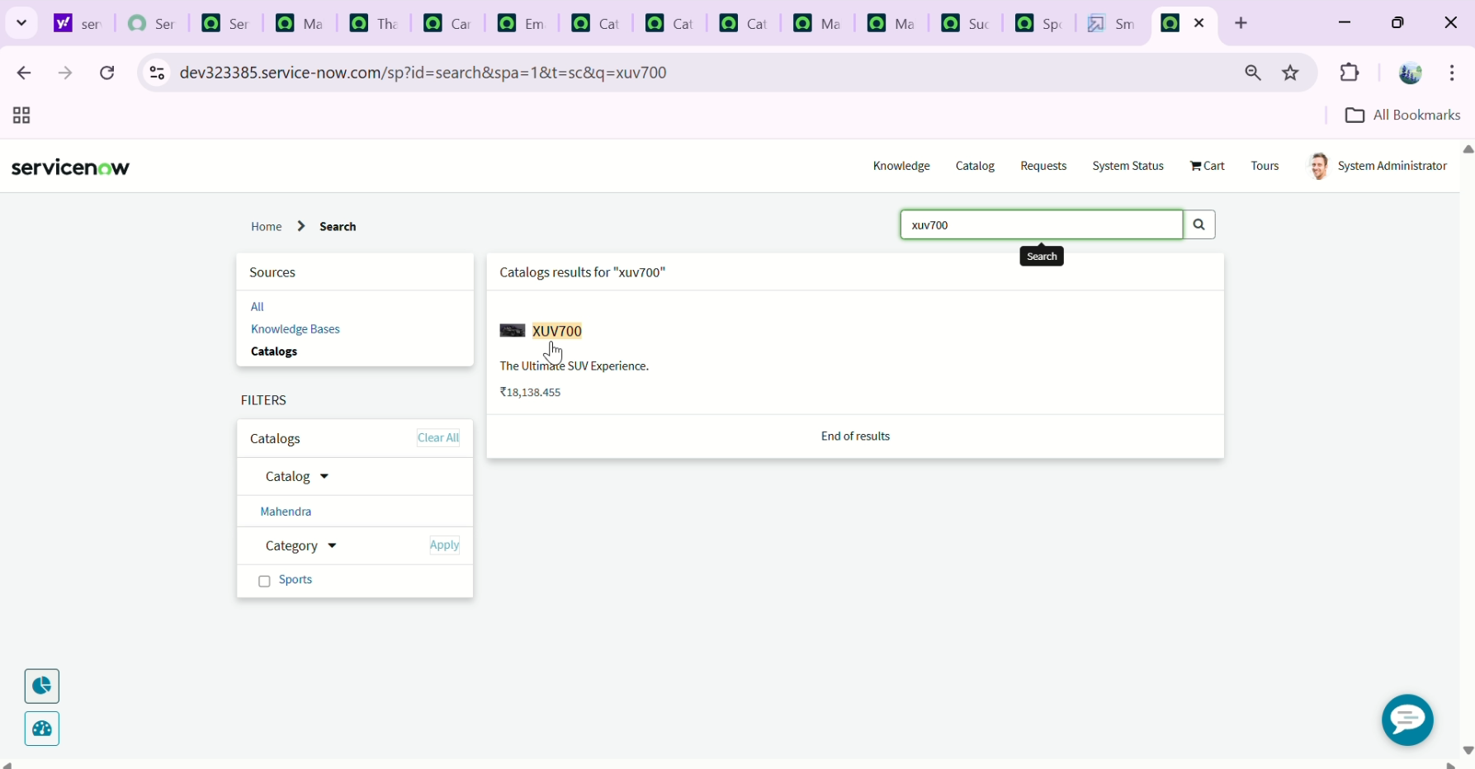

**Phase 2: Workflow Design**

The Flow Designer was used to create the automation logic.

Flow Components:

* Trigger
* Condition blocks
* Approval actions
* Task creation
* Notification actions

Approval hierarchy:

Level1–SalesPerson  
Level 2 – Supervisor

The flow ensures that if Level 1 rejects the request, it does not proceed to Level 2.

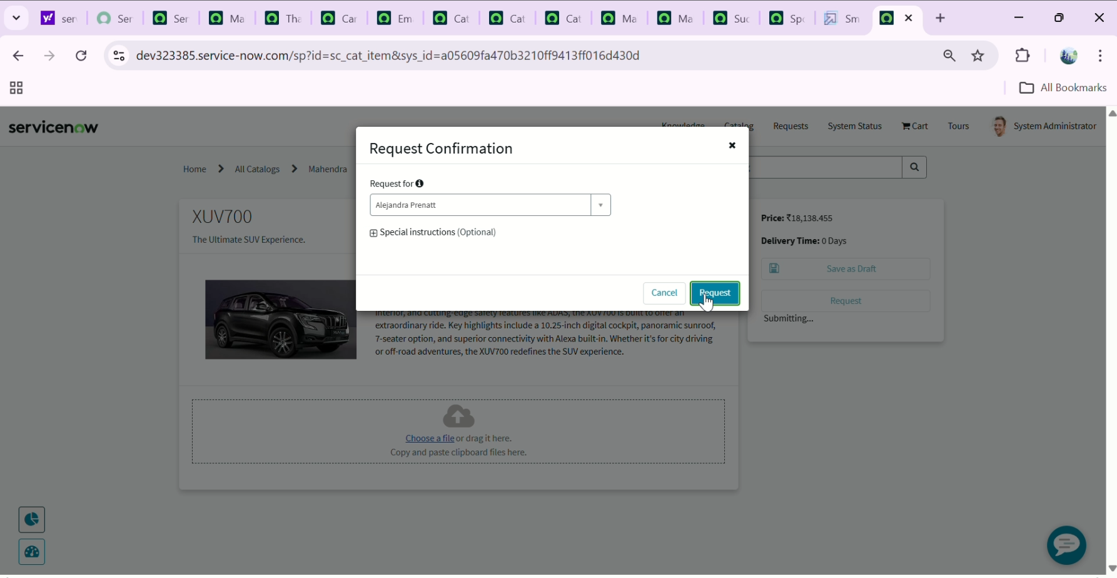

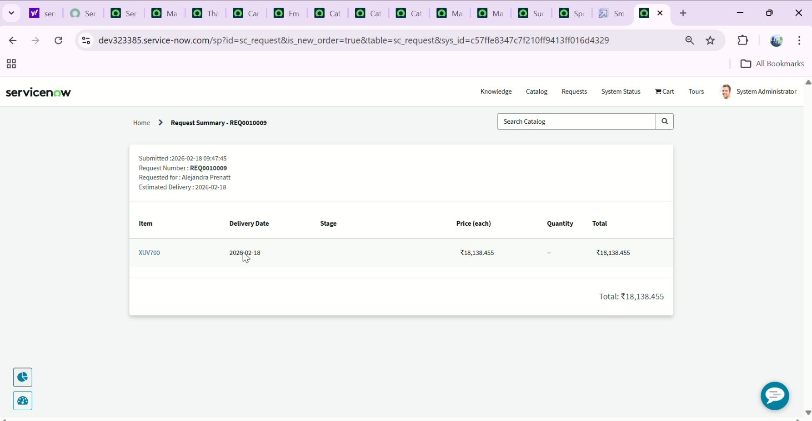

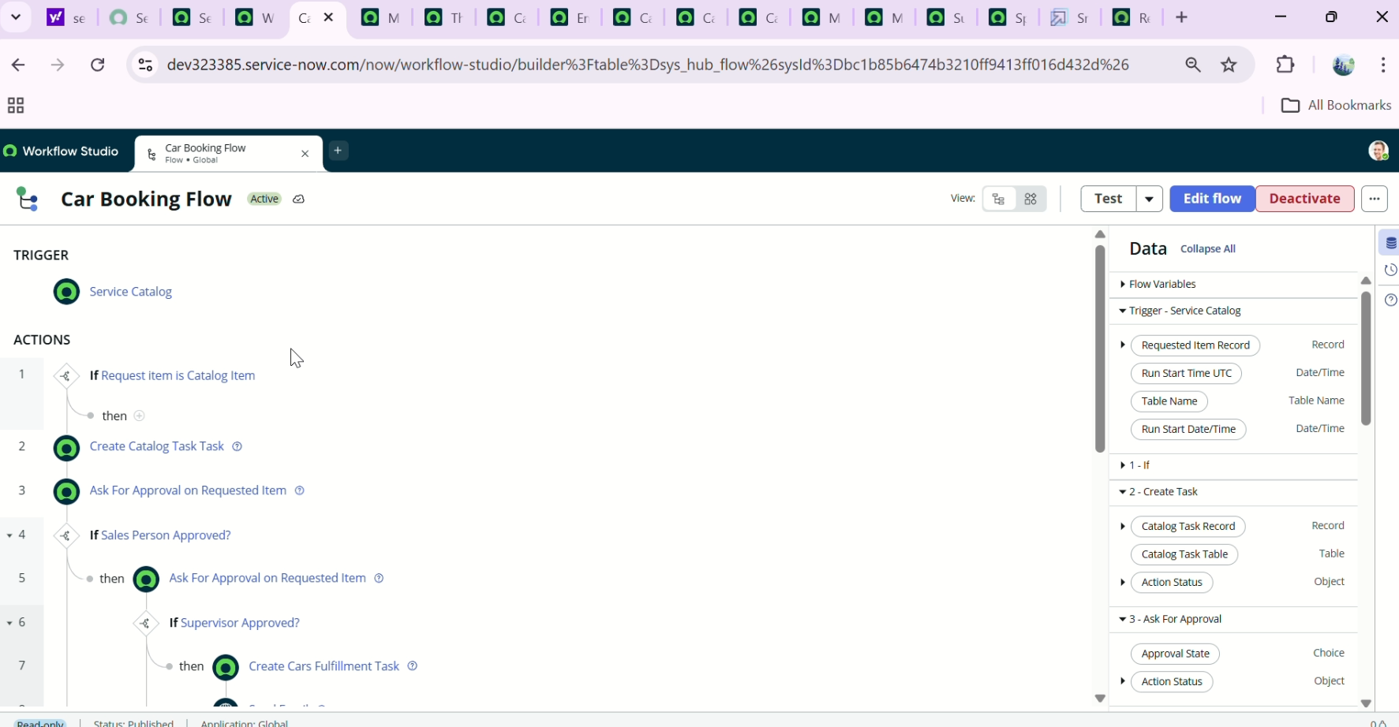

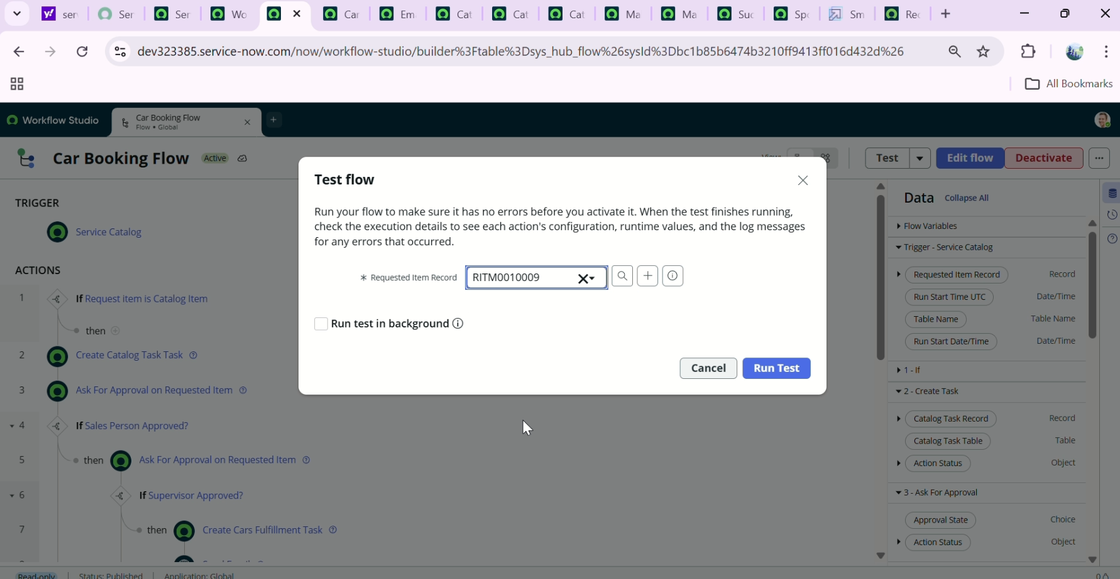

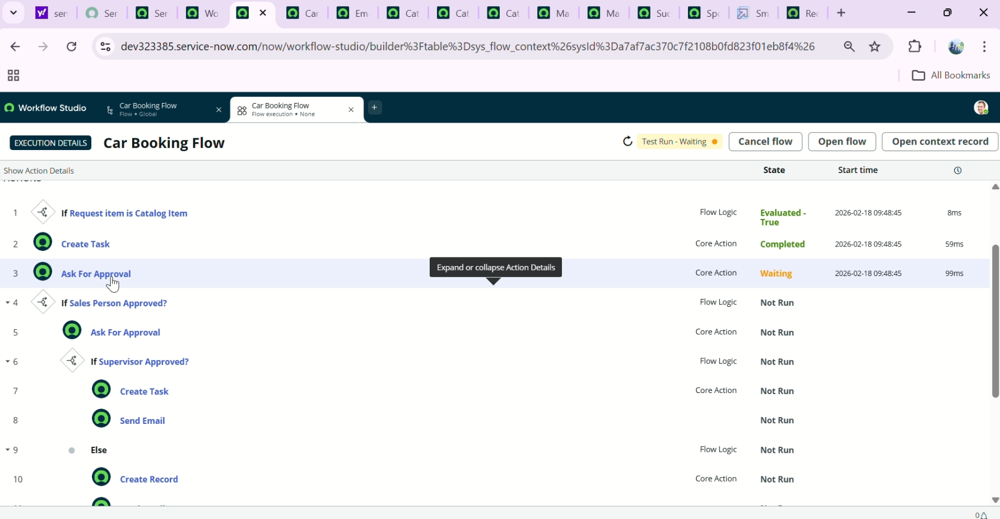

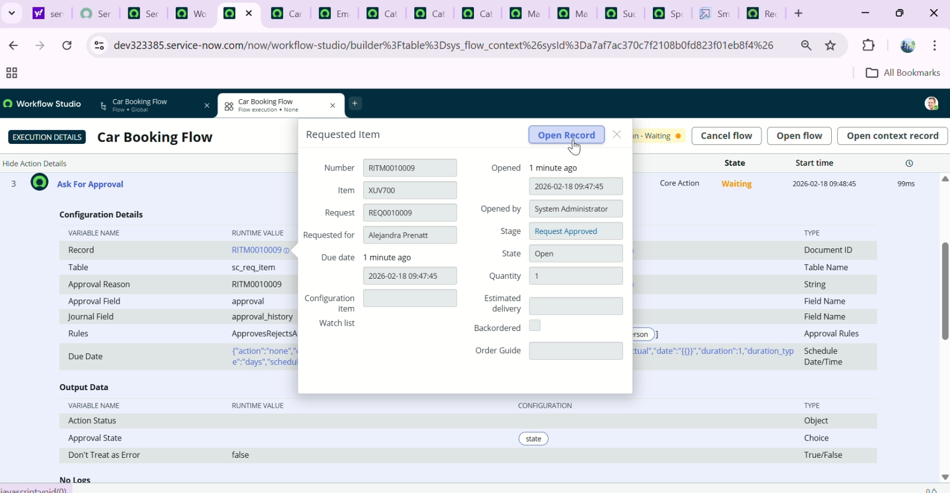

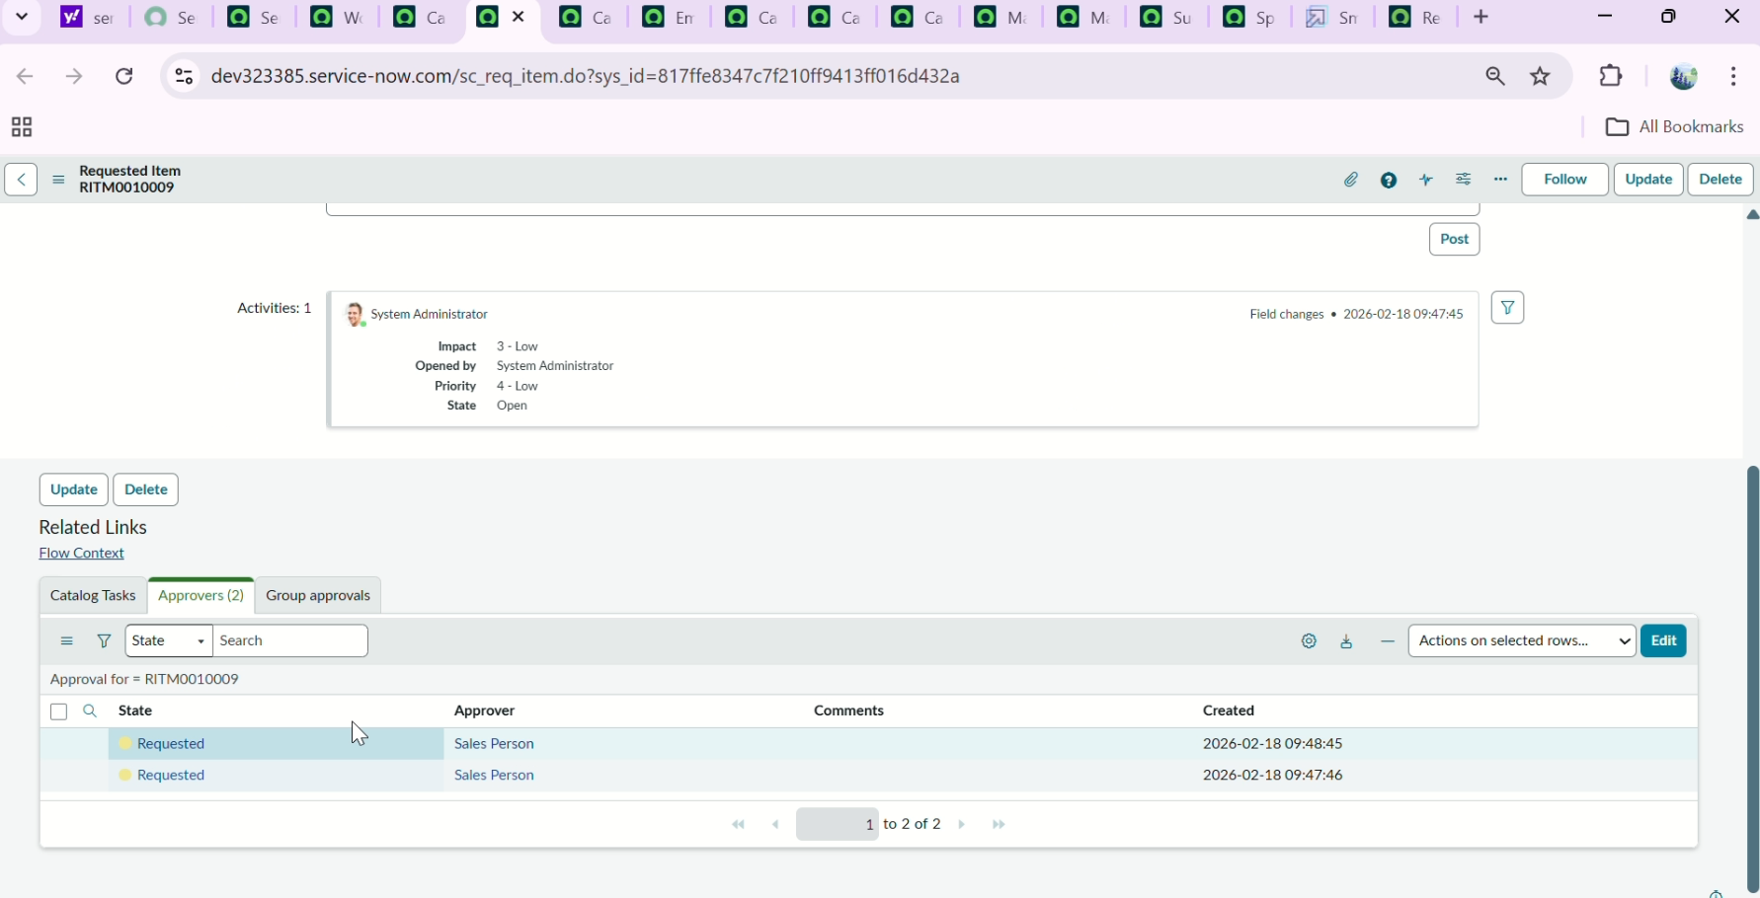

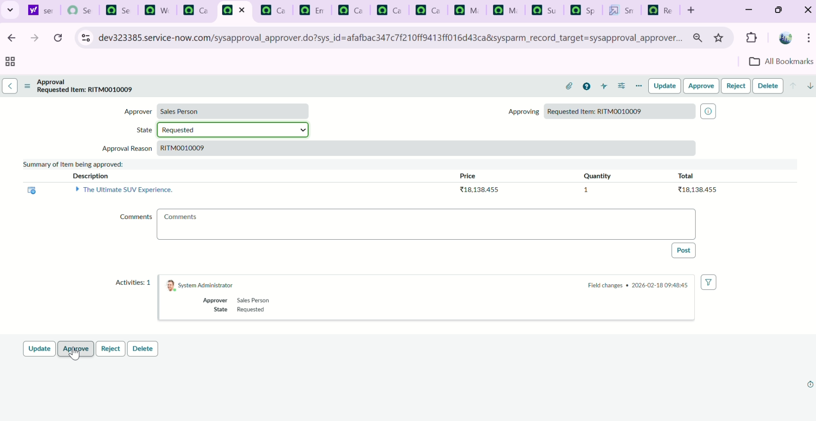

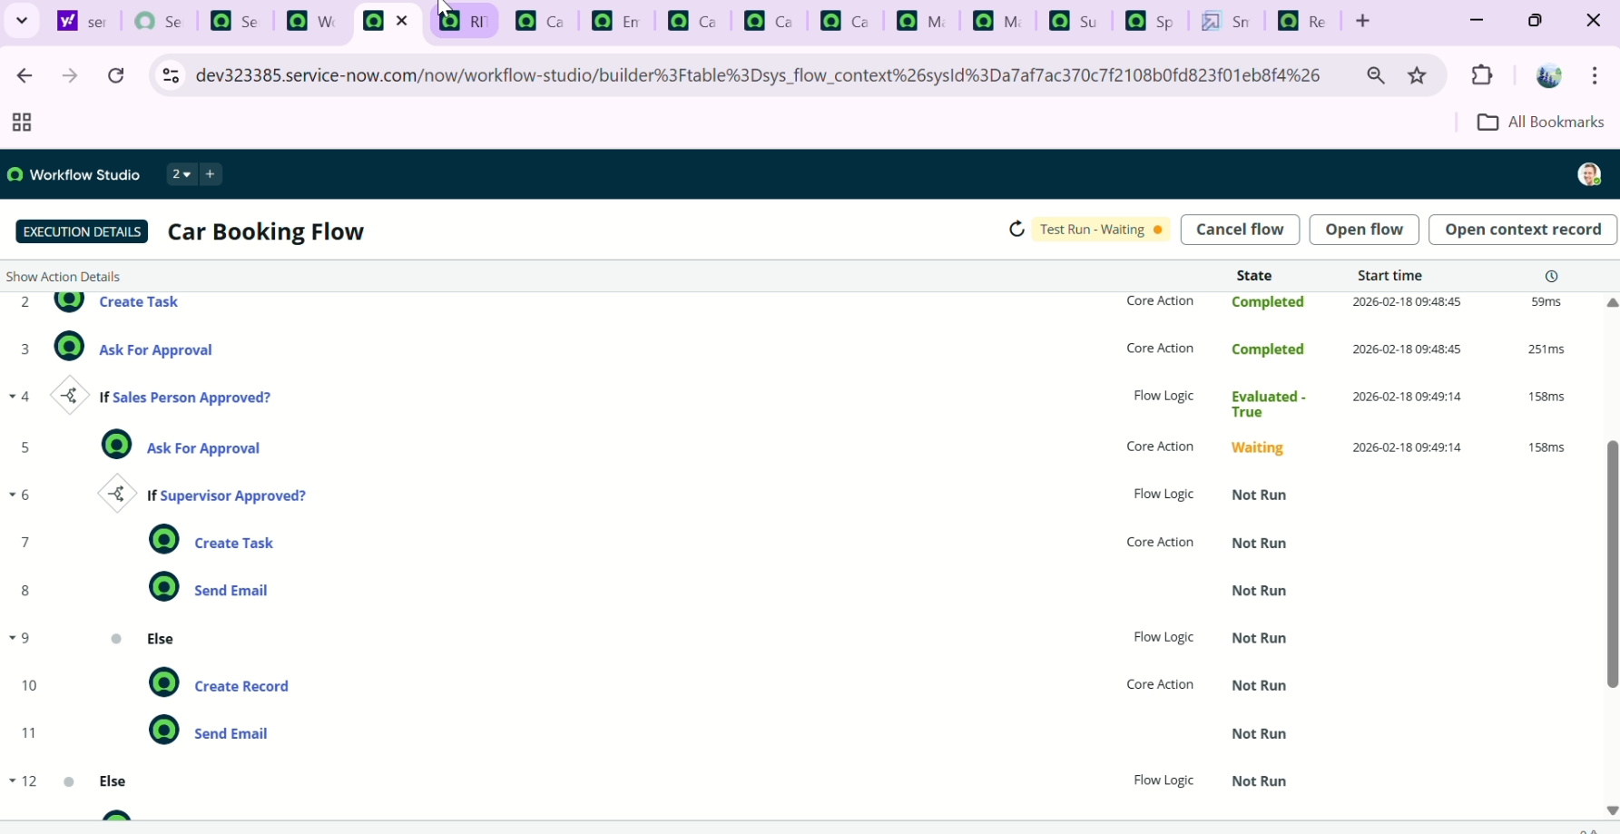

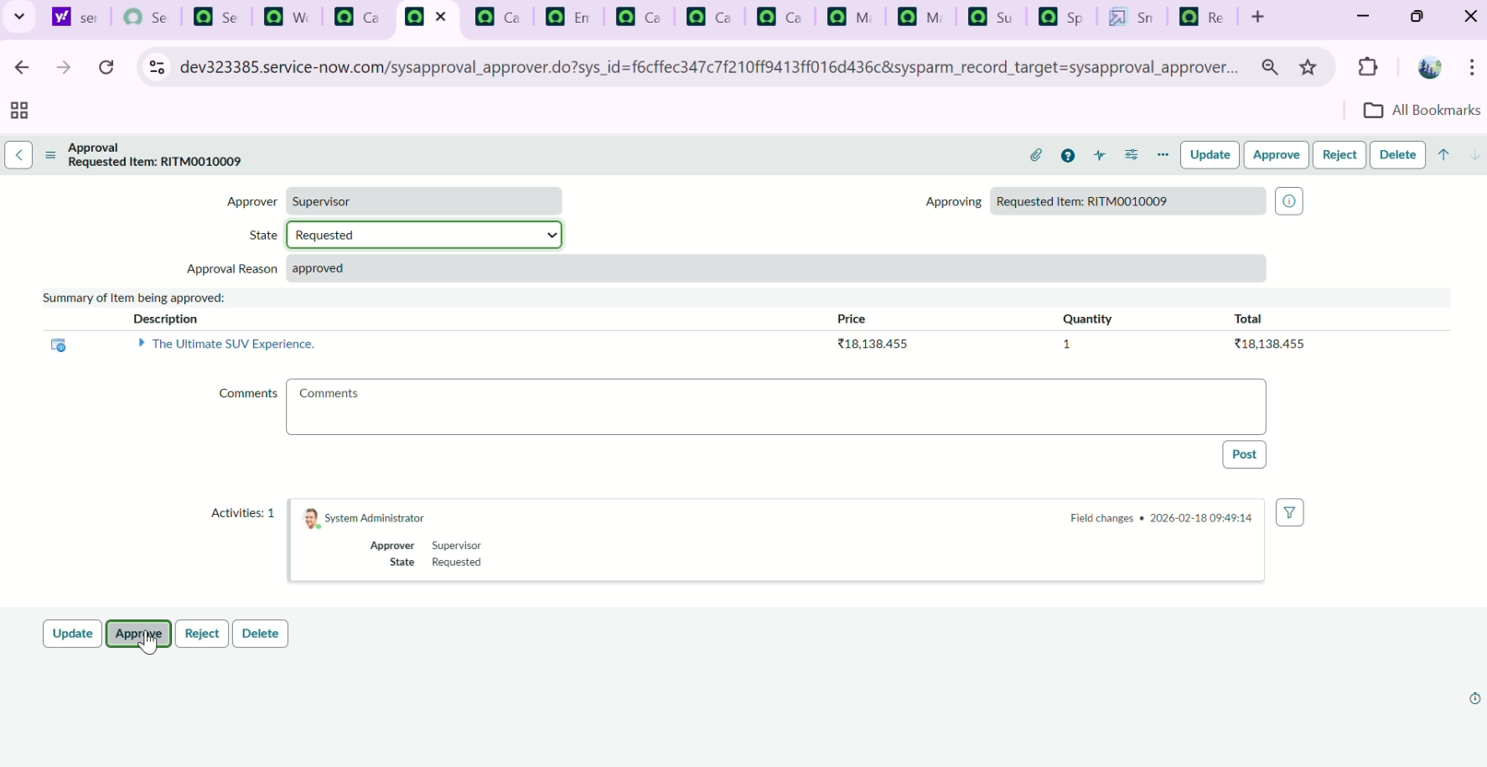

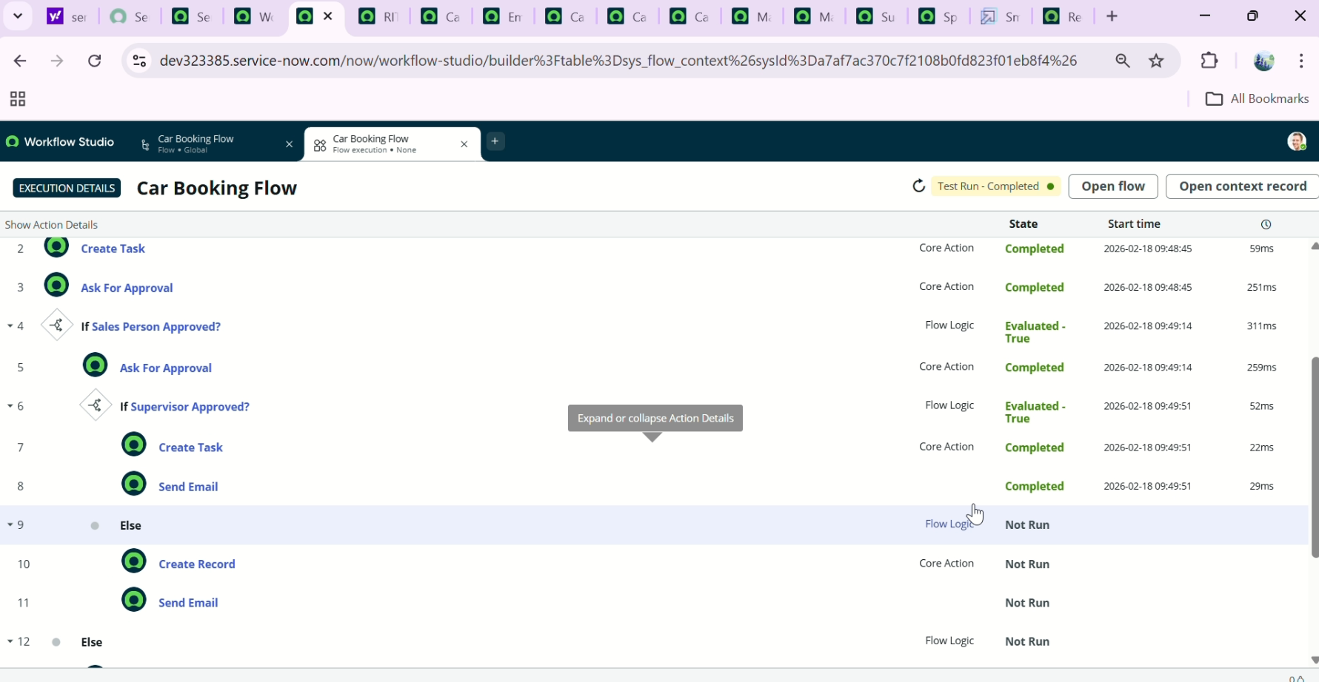

**Phase 3: Notifications**

Email notifications were configured to inform:

* Sales team of new booking
* Supervisor of pending approval
* Customer of approval success
* Customer of rejection

Notifications include dynamic fields such as:

* Customer name
* Car model
* Request number
* Approval comments

This improves communication transparency.

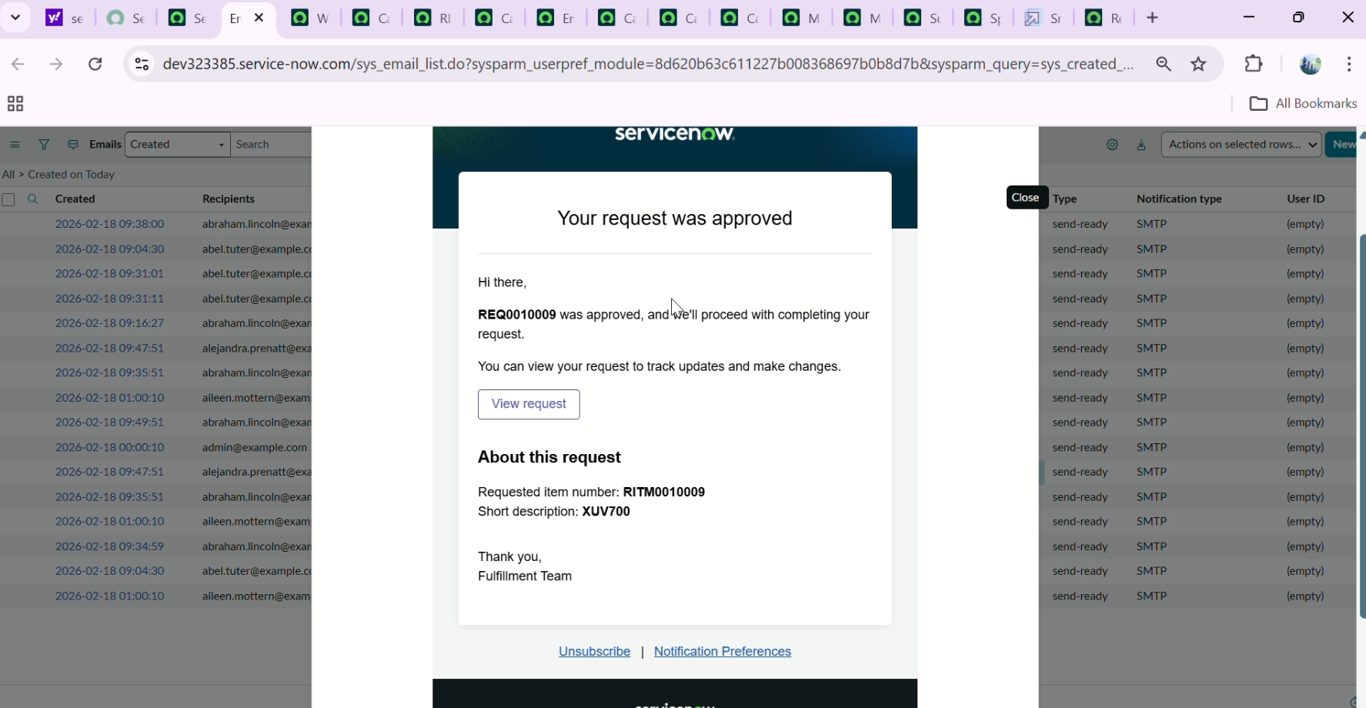

**Phase 4: Security Configuration**

Security was implemented using Role-Based Access Control.

Roles configured:

* Customer
* Sales Person
* Supervisor
* Administrator

Access restrictions:

* Only approvers can approve
* Customers can view only their requests
* Admin can configure workflows
* Task updates restricted to assigned group

This ensures data protection and operational control.

**5. Process Flow Lifecycle**

The booking lifecycle operates as follows:

Step 1: Customer submits booking  
Step 2: System creates request and requested item  
Step 3: Flow triggers automatically  
Step 4: Catalog task created  
Step 5: Sales approval requested  
Step 6: Supervisor approval requested  
Step 7: Status updated to approved  
Step 8: Notification sent  
Step 9: Process completed

**Flow Designer Automation:**

The automation backbone of the Mahendra Car Showroom system is implemented using Flow Designer in ServiceNow. This component is responsible for approval routing, decision-making logic, conditional branching, and execution of success or rejection paths.

The flow created for this project is named:“Car Booking Flow”

This flow ensures that every booking request follows a structured, rule-driven approval lifecycle.

**Purpose of Flow Designer Implementation:-**

The objective of this automation is to:

* Eliminate manual approval routing
* Enforce multi-level approval governance
* Automatically create tracking tasks
* Handle rejection scenarios logically
* Send appropriate notifications
* Maintain structured execution logs

The flow ensures process consistency for every booking request.

**Trigger Configuration:-**

The flow is triggered automatically when a booking request is created.

Trigger Details:

* Event Type: Service Catalog
* Table: Requested Item [sc_req_item]
* Condition: When record is created

**Flow Actions – Detailed Explanation:-**

The flow contains 12 structured actions designed with conditional routing logic.

**Action 1:** IF – Check Mahendra Catalog

Type: Flow Logic > If

Condition:  
Requested Item → Item → Name IS ONE OF:

* Thar
* Polo
* XUV700

Purpose:  
This step filters requests and ensures that only bookings related to Mahendra cars are processed by this flow. It prevents unintended execution for unrelated catalog items.

**Action 2:** Create Catalog Task

Type: Service Catalog > Create Catalog Task

Configuration:

* Short Description:  
  "Car booking for [Item Name]"
* Description:  
  "Car booked successfully"
* Assignment Group: Showroom

Purpose:  
Creates a structured work item for operational tracking. This allows the showroom team to monitor the progress of each booking.

**Action 3:** Ask for Approval – Sales Person

Type: Approvals > Ask for Approval

Configuration:

* Table: Requested Item
* Record: Trigger → Requested Item Record
* Approval Field: Approval
* Journal Field: Approval History
* Rule: Anyone approves or rejects
* Users: Sales Person

**Purpose:**  
This acts as the first-level approval gate. The booking cannot proceed without Sales approval.

**Action 4:** IF – Sales Person Approved?

Type: Flow Logic > If

Condition:  
Ask for Approval → Approval State IS Approved

Purpose:  
Routes the flow depending on the decision of the Sales Person.

If approved → Move to Supervisor approval  
If rejected → Trigger rejection handling

**Action 5:** Ask for Approval – Supervisor

Type: Approvals > Ask for Approval

Configuration:

* Table: Catalog Task
* Record: Created Catalog Task Record
* Approval Field: Approval
* Rule: Anyone approves or rejects
* Users: Supervisor

Purpose:  
This is the second-level governance checkpoint.

This action executes only if the Sales Person approves.

**Action 6:** IF – Supervisor Approved?

Type: Flow Logic > If

Condition:  
Supervisor Approval State IS Approved

Purpose:  
Determines whether the booking moves to success handling or rejection handling.

**Action 7:** Create Record – Success

Type: Service Catalog > Create Catalog Record

Configuration:

* Table: Catalog [sc_catalog]
* Fields:
  + Description: "Car ready for pickup"
  + Short Description: "Car booking approved"

Purpose:  
Creates a tracking record indicating successful booking approval.

This executes only if both approvals are granted.

**Action 8:** Send Email – Success

Type: Notifications > Send Email

Configuration:

* To: Abraham Lincoln (User)
* Subject: "Car Booking Approved - Mahendra Showroom"
* Body: HTML Template

Purpose:  
Notifies stakeholders that the booking has been approved.

**Action 9:** Create Record – Rejection (Sales)

Type: Service Catalog > Create Catalog Record

Configuration:

* Table: Catalog [sc_catalog]
* Fields:
  + Description: "Car booking rejected by Sales Person"
  + Short Description: "Car deployment failed"

Purpose:  
Tracks rejection at the first level.

**Action 10:** Send Email – Rejection (Sales)

Type: Notifications > Send Email

Configuration:

* To: Abraham Lincoln
* Subject: "Car Booking Rejected - Mahendra Showroom"
* Body: HTML Template

Purpose:  
Notifies stakeholders about Sales-level rejection.

**Action 11:** Create Record – Rejection (Supervisor)

Type: Service Catalog > Create Catalog Record

Configuration:

* Table: Catalog [sc_catalog]
* Description: "Car booking rejected by Supervisor"

Purpose:  
Tracks rejection at second approval level.

**Action 12:** Send Email – Rejection (Supervisor)

Type: Notifications > Send Email

Configuration:

* To: Abraham Lincoln
* Subject: "Car Booking Rejected - Mahendra Showroom"
* Body: HTML Template

Purpose:  
Notifies stakeholders about Supervisor-level rejection.

**Email Notification System:**

The email system is implemented using ServiceNow’s built-in email engine. Its purpose is to ensure proactive communication with stakeholders and maintain professional correspondence standards.

* **Email Template Implementation**

The system uses custom HTML code inside ServiceNow notification configuration to create visually styled emails.

**Approval Email Template** (HTML Code Used)

<div style="font-family: Arial; padding: 20px; background: #e8f5e9;

border-radius: 8px; border: 2px solid #4CAF50;">

<h2 style="color: #2e7d32;">🎉 Car Request Approved!</h2>

<p>Your car booking has been approved.</p>

<div style="background: white; padding: 15px; margin: 15px 0;">

<p><strong>Request Status:</strong> Approved ✓</p>

<p><strong>Car Status:</strong> Ready for Pickup</p>

<p><strong>Next Steps:</strong> Our team will contact you.</p>

</div>

<p><strong>Thank you for choosing Mahendra!</strong></p>

</div>

**Rejection Email Template** (HTML Code Used)

<div style="font-family: Arial; padding: 20px; background: #ffebee;

border-radius: 8px; border: 2px solid #f44336;">

<h2 style="color: #c62828;">❌ Car Booking Rejected</h2>

<p>Unfortunately, your car booking has been rejected.</p>

<div style="background: white; padding: 15px; margin: 15px 0;">

<p><strong>Request Status:</strong> Rejected ✗</p>

<p><strong>Rejected By:</strong> [Approver]</p>

</div>

<p>Please contact the showroom for more information.</p>

</div>

**Email Configuration Details :**

* Recipients: Abraham Lincoln (User), Showroom (Group)
* Format: HTML
* Dynamic Fields:
  + Car Name
  + Approval Status
  + Approver Name
  + Request Number
* Delivery Engine: ServiceNow Email Engine
* Logging: Email logs stored in system for tracking

The use of HTML ensures:

* Professional appearance
* Color-coded status visibility
* Structured information presentation
* Improved user experience

**6. Testing Strategy**

Comprehensive testing was conducted to validate functionality.

**Functional Testing**

* Verified catalog item visibility
* Tested booking submission
* Validated approval routing
* Verified rejection handling
* Checked email delivery

**Integration Testing**

* End-to-end lifecycle testing
* Multi-user testing
* Role validation

**Security Testing**

* Unauthorized approval attempt
* Role restriction verification
* Table access validation

**Performance Testing**

* Multiple simultaneous booking submissions
* Approval queue handling
* Workflow execution validation

All major test cases were successfully executed.

**7. Challenges Faced**

* Understanding approval routing logic
* Configuring conditional flows
* Managing role permissions correctly
* Debugging flow execution errors
* Email configuration troubleshooting

These challenges were resolved through systematic testing and configuration review.

**8. Known Limitations**

* No real-time inventory management
* No payment integration
* No SMS notifications
* No analytics dashboard

These are considered future scope enhancements.

**9. Future Enhancements**

* Inventory validation system
* Payment gateway integration
* Dashboard for management reporting
* SLA-based escalation
* Mobile app extension
* CRM integration
* AI-based approval recommendation

These features can further enhance operational efficiency.

**10. Conclusion**

The Mahendra Car Showroom Automation System successfully demonstrates how enterprise workflows can be automated using ServiceNow.

The system achieves:

* Reduced processing time
* Improved transparency
* Standardized approval workflow
* Enhanced customer experience
* Secure and auditable operations

This project proves that ServiceNow can be effectively used for business process automation beyond IT service management.The implementation is scalable, secure, and ready for enterprise-level deployment.